AI Medical Report Generator from Chest X-Ray Images Using Deep Learning and Transfer Learning

Technical Report
Submitted By
Aravind Nagaraj Kavadikeri (20241CSD0117)
Ankit A Hegde (20241ISE0115)
Indushree S (20241ISE0157)
Goutam Ganesh Bhat (20241IST0116)
Institution
Presidency University, Bangalore

Abstract
Medical image analysis has become one of the most impactful applications of Artificial Intelligence in healthcare. Chest X-ray interpretation is an essential diagnostic procedure used for detecting respiratory diseases such as COVID-19 and Viral Pneumonia. However, manual examination of X-ray images requires experienced radiologists and can be time-consuming.
This project presents an AI-powered Medical Report Generator that automatically classifies chest X-ray images into three categories: COVID-19, Viral Pneumonia, and Normal. The system employs Deep Learning and Transfer Learning techniques using CNN, VGG16, ResNet50, and DenseNet121 architectures. After classification, the application automatically generates a structured medical report containing disease prediction, confidence score, severity level, symptoms, diagnostic recommendations, treatment suggestions, and medical disclaimers.
Experimental results show that VGG16 and DenseNet121 achieved the highest accuracy of 84.85%, demonstrating the effectiveness of transfer learning for medical image analysis.
Keywords: Deep Learning, Transfer Learning, Medical Imaging, Chest X-Ray, COVID-19 Detection, CNN, VGG16, DenseNet121, Artificial Intelligence, Healthcare.

Chapter 1: Introduction
1.1 Background
Artificial Intelligence is revolutionizing healthcare by assisting medical professionals in diagnosis, treatment planning, and disease monitoring. Medical imaging is one of the most important areas where AI can significantly improve efficiency and accuracy.
Chest X-ray imaging is commonly used to diagnose respiratory diseases. During the COVID-19 pandemic, rapid and accurate screening became crucial. AI-based systems can support healthcare professionals by providing preliminary diagnoses and reducing workload.
1.2 Problem Statement
Manual interpretation of chest X-rays requires expert radiologists and considerable time. In many regions, limited access to specialists delays diagnosis and treatment.
The challenge is to develop an automated system capable of:
- • Classifying chest X-rays accurately.
- • Generating structured medical reports.
- • Assisting healthcare professionals in preliminary diagnosis.
1.3 Objectives
The objectives of this project are:
- • Develop an automated chest X-ray classification system.
- • Compare multiple deep learning architectures.
- • Identify the best-performing model.
- • Generate comprehensive medical reports automatically.
- • Improve accessibility to diagnostic support systems.

Chapter 2: Literature Survey
Recent advancements in deep learning have demonstrated significant success in medical image classification.
CNN-Based Systems
Convolutional Neural Networks automatically learn image features and have achieved strong performance in disease detection tasks.
Transfer Learning Approaches
Pre-trained models such as VGG16, ResNet50, and DenseNet121 utilize knowledge gained from large-scale datasets like ImageNet and adapt it for medical applications.
Automated Medical Reporting
Modern AI systems increasingly focus on combining image classification with report generation to provide clinically meaningful outputs.

Chapter 3: Dataset Description
3.1 Dataset Source
The project utilizes the COVID-19 Chest X-Ray Dataset obtained from Kaggle.
3.2 Dataset Composition
The dataset contains chest X-ray images belonging to:
- • COVID-19
- • Viral Pneumonia
- • Normal
Dataset Statistics:
- • Training Images: 251
- • Testing Images: 66
- • Total Images: 317
3.3 Data Preprocessing
Preprocessing steps include:
- • Image resizing to 224 × 224 pixels.
- • Pixel normalization using rescaling (1/255).
- • Batch size of 32.
- • Data loading using TensorFlow ImageDataGenerator.

Chapter 4: System Architecture
4.1 Workflow
The complete workflow follows:
- 1. Dataset Loading
- 2. Image Preprocessing
- 3. Model Training
- 4. Model Evaluation
- 5. Best Model Selection
- 6. Disease Prediction
- 7. Medical Report Generation
- 8. PDF Export
4.2 Software Tools
Programming Language
- • Python
Libraries Used
- • TensorFlow
- • Keras
- • NumPy
- • Pandas
- • Matplotlib
- • Seaborn
- • Scikit-Learn
- • ReportLab

Chapter 5: Methodology
5.1 CNN Model
A custom CNN architecture was developed consisting of:
- • Conv2D (32 filters)
- • MaxPooling
- • Conv2D (64 filters)
- • MaxPooling
- • Conv2D (128 filters)
- • MaxPooling
- • Flatten Layer
- • Dense Layer (256 neurons)
- • Dropout (0.5)
- • Softmax Output Layer
5.2 VGG16 Model
VGG16 is a deep convolutional neural network containing 16 layers.
Features:
- • ImageNet Pre-trained Weights
- • Frozen Convolutional Base
- • Global Average Pooling
- • Dense Layer (256)
- • Dropout Layer
5.3 ResNet50 Model
ResNet50 utilizes residual learning through skip connections.
Advantages:
- • Prevents vanishing gradients
- • Supports deeper architectures
- • Improved feature extraction
5.4 DenseNet121 Model
DenseNet121 uses dense connectivity where each layer receives information from all preceding layers.
Advantages:
- • Better feature reuse
- • Reduced parameter redundancy
- • Improved gradient flow

Chapter 6: Experimental Setup
Training Parameters
Parameter | Value
Image Size | 224 × 224
Batch Size | 32
Epochs | 5
Optimizer | Adam
Loss Function | Categorical Cross Entropy
Activation | ReLU / Softmax
Hardware Requirements
- • GPU-enabled environment
- • Minimum 8 GB RAM
- • TensorFlow-compatible GPU

Chapter 7: Results and Analysis
Model Performance Comparison
Model | Accuracy
CNN | 81.82%
VGG16 | 84.85%
ResNet50 | 80.30%
DenseNet121 | 84.85%

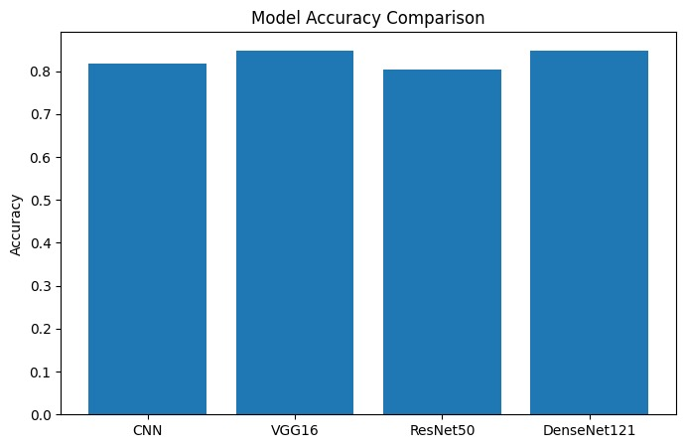
Best Performing Models
- • VGG16 – 84.85%
- • DenseNet121 – 84.85%
VGG16 was selected as the final model due to its balanced performance and training stability.
Classification Metrics
COVID-19
- • Precision: 89%
- • Recall: 89%
- • F1 Score: 89%
Normal
- • Precision: 82%
- • Recall: 82%
- • F1 Score: 82%
Viral Pneumonia
- • Precision: 83%
- • Recall: 83%
- • F1 Score: 83%
Overall Accuracy: 84.85%

Chapter 8: Medical Report Generation
After disease prediction, the system automatically generates a PDF report containing:
Patient Report Contents
• Disease Prediction: COVID-19 / Viral Pneumonia / Normal
• Confidence Score: Softmax probability percentage
• Severity Level: High / Moderate / Low
• Symptoms: Disease-specific symptoms retrieved from medical datasets.
• Diagnostic Tests: Recommended medical examinations.
• Treatment Recommendations: Suggested treatments and precautions.
• Disclaimer: AI-generated report intended for assistance only. Professional medical consultation is required.

Chapter 9: Applications
• Healthcare Diagnostics: Provides rapid preliminary disease screening.
• Telemedicine: Supports remote healthcare services.
• COVID-19 Screening: Enables mass screening during outbreaks.
• Medical Education: Useful for training medical students.
• Cloud-Based Deployment: Can be integrated into web and mobile healthcare platforms.
• Research Applications: Supports large-scale medical imaging studies.

Chapter 10: Challenges and Limitations
Challenges:
• Small Dataset: Only 317 images were available, limiting generalization.
• Class Imbalance: Unequal class distribution affects performance.
• Limited Training: Models were trained for only 5 epochs.
• Frozen Transfer Learning Layers: Fine-tuning was not performed.
Limitations
- • Not suitable for clinical diagnosis without validation.
- • Limited disease categories.
- • Requires larger datasets for real-world deployment.

Chapter 11: Future Scope
Future improvements include:
• Multi-Disease Detection: Adding Tuberculosis, Lung Cancer, and Pleural Effusion.
• GAN-Based Data Augmentation: Generating synthetic X-rays to improve dataset balance.
• Grad-CAM Explainability: Visualizing regions influencing predictions.
• Mobile and Cloud Deployment: Developing Android, iOS, and web applications.
• EHR Integration: Connecting with Electronic Health Records systems.
• Fine-Tuning: Training top layers of transfer learning models for 20+ epochs to improve accuracy.

Chapter 12: Conclusion
This project successfully demonstrates the application of Deep Learning and Transfer Learning for automated chest X-ray analysis and medical report generation. Four different models were evaluated, and VGG16 along with DenseNet121 achieved the highest accuracy of 84.85%.
The developed system not only classifies diseases but also generates structured PDF reports, making it a complete end-to-end healthcare AI solution. Such systems can assist healthcare professionals, support telemedicine services, and contribute to faster medical diagnosis in resource-limited environments.
The project represents a significant step toward intelligent, accessible, and AI-assisted healthcare systems.

References
- [1] TensorFlow Documentation.
- [2] Keras Deep Learning Library.
- [3] COVID-19 Chest X-Ray Dataset (Kaggle).
- [4] VGG16 Research Paper.
- [5] ResNet50 Research Paper.
- [6] DenseNet121 Research Paper.
- [7] Scikit-Learn Documentation.
- [8] ReportLab PDF Generation Documentation.

